Supplementary Information
Enhanced transferrin modified targeting delivery system via AFP promoter MR imaging reporter gene transfection

Jiaping Zhou¹, Qiaomei Zhou¹, Gaofeng Shu², Xiaojie Wang¹, Yuanfei Lu¹, Haiyan Chen¹, Tingting Hu¹, Jinsong Cai¹, Yongzhong Du²*, and Risheng Yu¹*

¹Department of Radiology, Second Affiliated Hospital, School of Medicine, Zhejiang University, Hangzhou 310009, China
²Institute of Pharmaceutics, College of Pharmaceutical Sciences, Zhejiang University, Hangzhou 310058, China

Corresponding authors:
E-mail: risheng-yu@zju.edu.cn; Tel.: +8613757118387; Fax: +8657187784556
E-mail: duyongzhong@zju.edu.cn; Tel.: +8657188208435; Fax: +8657188208435

CONTENTS
Figure S1. Standard curve of doxorubicin.
Figure S2. Major organs tissue sections stained with H&E.

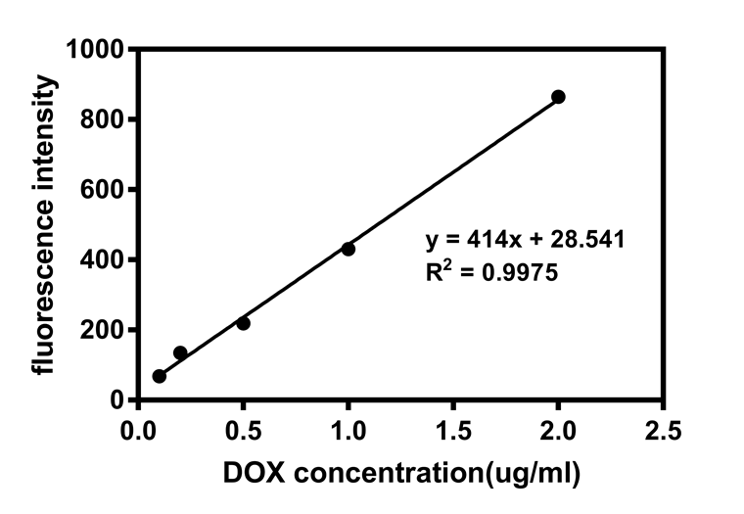
Figure S1. Standard curve of doxorubicin.

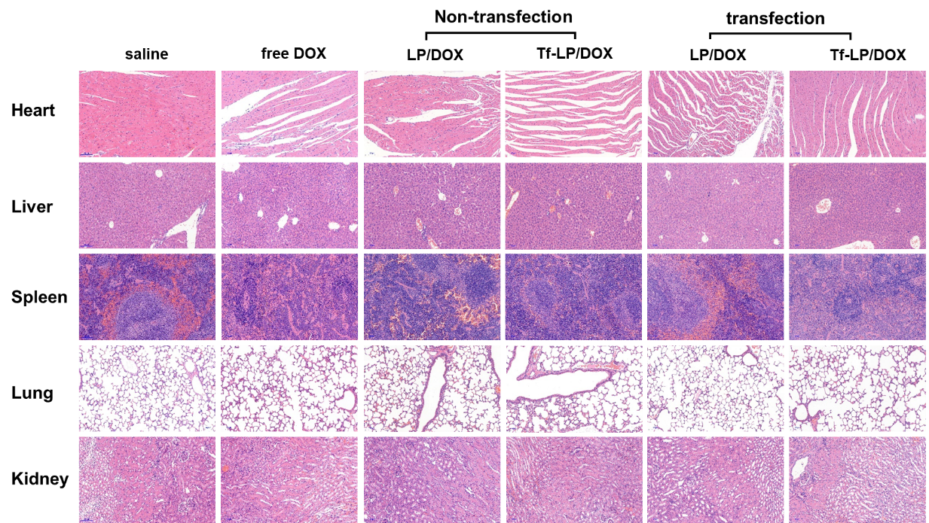

Figure S2. Histopathology images of heart, liver, spleen, lung, and kidney collected from all treatment groups.

